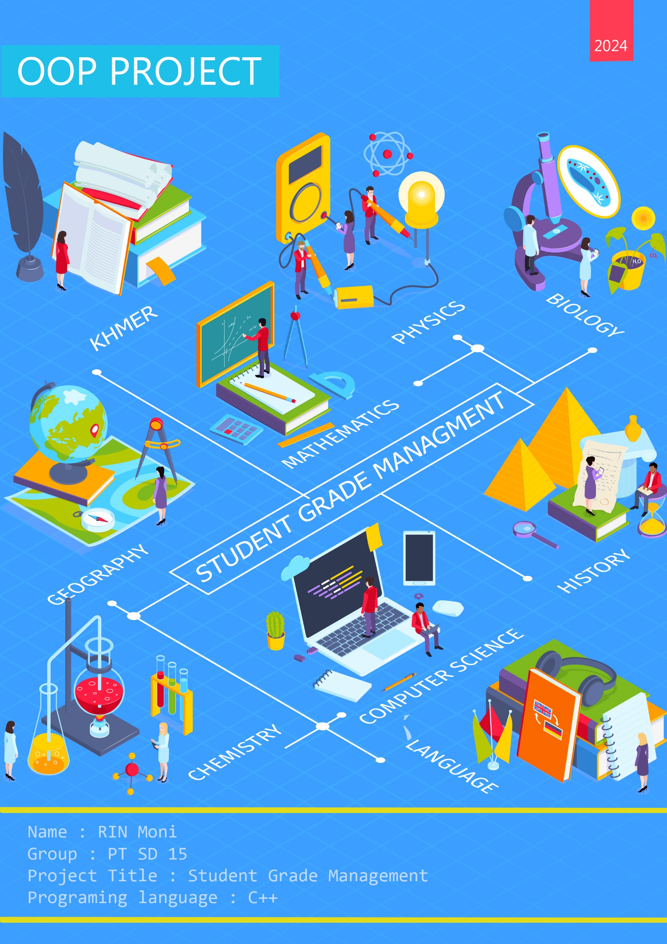

Project : STUDENT MANAGEMENT SYSTEM

* Project Descriptions:

The Student Management System project was developed in the C++ programming language. This system is built on the idea of keeping and creating all of the students' records. This application also includes a simple database of students for a school where the user may enter student information safely and conveniently. This system makes it simple for teachers to keep track of each student's progress. Furthermore, change and delete the information. This mini-project is also simple to use and comprehend for users.

* Application Modules
  1. Student login
  2. Teacher log in
  3. Admin log in
* User Features
  1. Student

* + 1. View Info
    2. View Record
    3. Change username
    4. Modify password
  1. Teacher
     1. Add student record
     2. Search student
     3. Update student record
     4. View student record
     5. Change username
     6. Modify password
  2. Admin
     1. Add student account
     2. Add teacher account
     3. Search user
     4. Sort user list
     5. View user list
     6. Update user account
     7. Remove user account
     8. Save
     9. Load
* Project Design

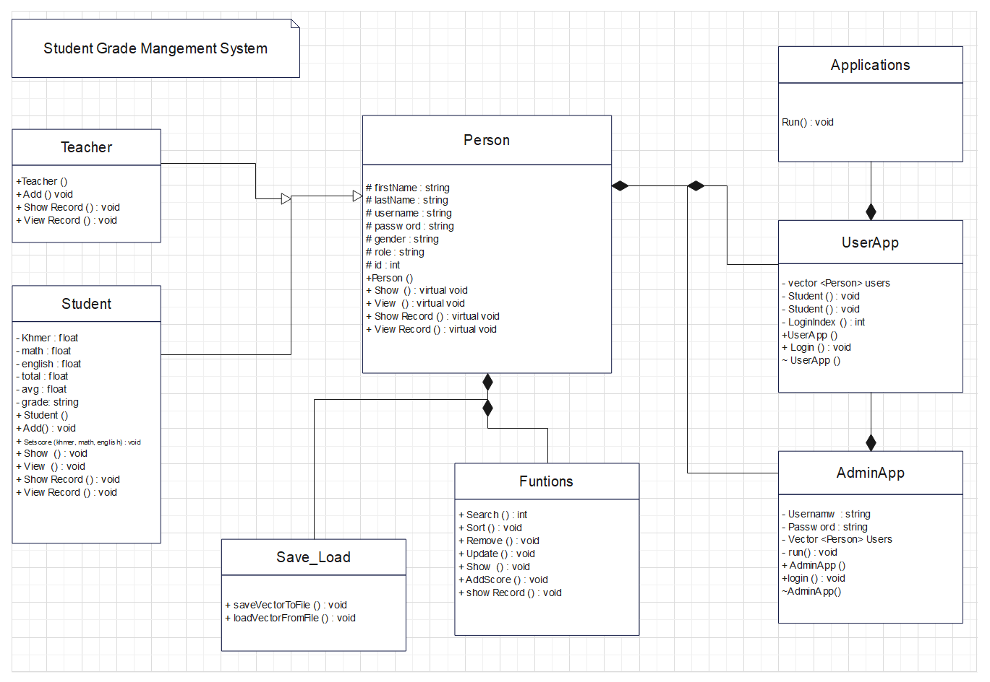1.Logical Design

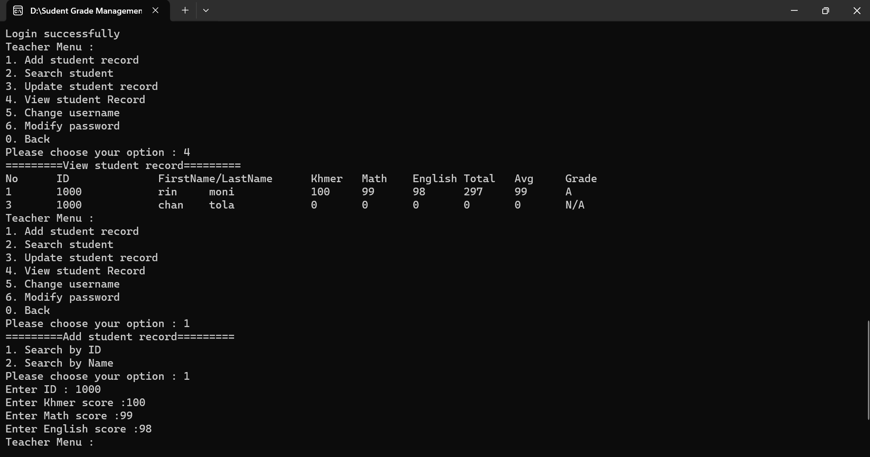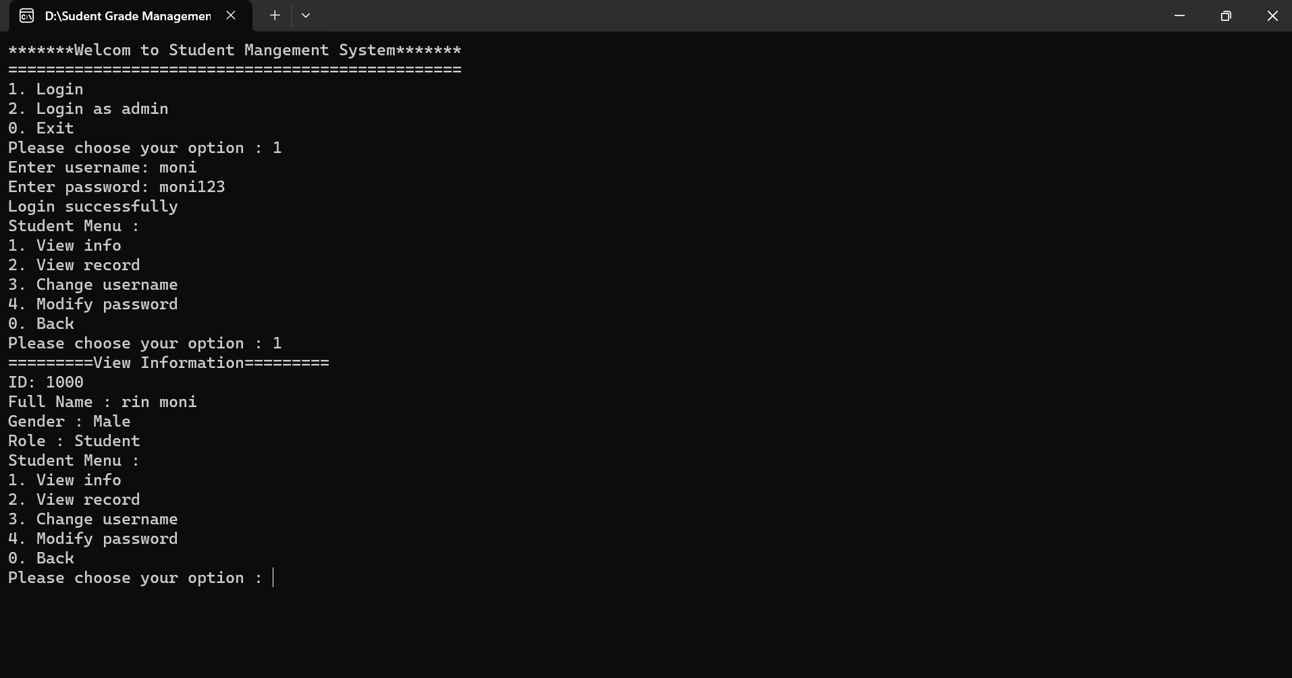2. Physical Design

